DATA FLOW DIAGRAM

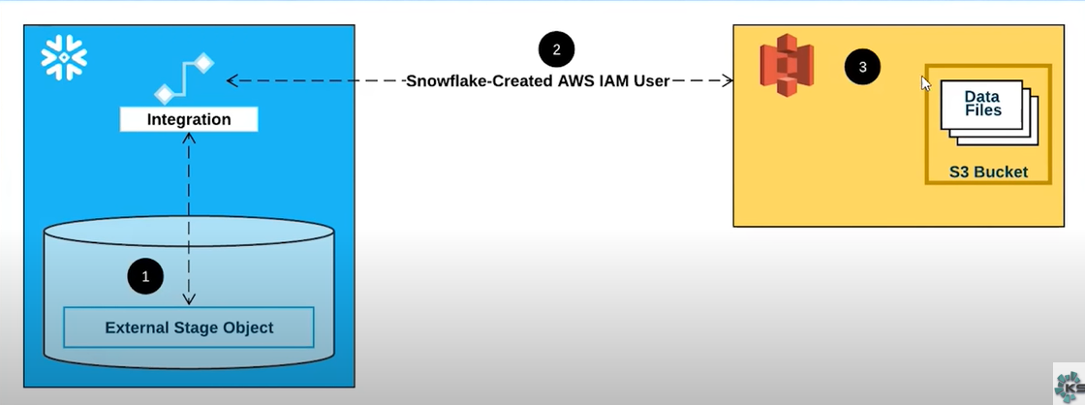

Objective: Read the file from S3 bucket and make it available in snowflake env.

So to support the above we need the following:

1.AWS S3 Bucket creation

2.AWS permissions for authentication

3.Integration object : A storage integration is a Snowflake object that stores a generated identity and access management (IAM) entity for your external cloud storage, along with an optional set of allowed or blocked storage locations

4.External Stage Object: A storage integration is a Snowflake object that stores a generated identity and access management (IAM) entity for your external cloud storage, along with an optional set of allowed or blocked storage locations

STEPs.

1.Create S3 bucket :

a.Give it a name and keep everything as default.

b.Upload file to the bucket

c.Open the file in S3.The following is the path of the file

S3 URI: s3:// /snowflake-s3-shreya /netflix_titles.csv

2.Create permissions/Role so that 3rd party can communicate with AWS:

a.IAM>>policies>>create policy>>JSON>> copy paste json from S3-policy file from your local ,giv it a name and create policies.

b. IAM>>policies>>create roles>>aws account>>attach the name to the policy created and a.aws account because we are giving access to 3rd party

b. This account (516915275482)

c.Copy paste the above in the external ID

>>attach the role to the policy created and create role>>click on to the role and copy the arn no. (arn:aws:iam::516915275482:role/snowflake-aws-shreya)

3.Create database,schema,storage integration(refer snowflake.txt)

Like AWS has created the arn similar to that snowflake will also create an external id and arn which needs to be communicated to aws.

Snowflake arn : arn:aws:iam::516915275482:role/snowflake-s3-shreya

Snowflake external Id : PC46691_SFCRole=2_i8FvJBQdxjklSfKAVRsDmjc7z/Y=

4. Map 3rd party(snowflake) details to roles of AWS

[IAM](https://us-east-1.console.aws.amazon.com/iamv2/home?region=ap-south-1#/home)>>[Roles](https://us-east-1.console.aws.amazon.com/iamv2/home?region=ap-south-1#/roles)>>[snowflake-aws-shreya](https://us-east-1.console.aws.amazon.com/iamv2/home?region=ap-south-1#/roles/details/snowflake-aws-shreya)>>Trust Relationship>>**Edit trust policy>> add the above arn and external id to the code**

{

"Version": "2012-10-17",

"Statement": [

{

"Effect": "Allow",

"Principal": {

"AWS": "arn:aws:iam::463934274011:user/o8eb0000-s"

},

"Action": "sts:AssumeRole",

"Condition": {

"StringEquals": {

"sts:ExternalId": "PC46691_SFCRole=2_vpKEcDLEJFPf4hHD6/vbGlFhXnc="

}

}

}

]

}

5.Create External Stage : To load file from 3rd party we will be creating external stage but before that we need to create file format.

a.Create file format

b.Create external stage

6.Create temporary table : To load data from files from s3 bucket into the table.